What is World Mission Sunday?
World Mission Sunday, which is celebrated on the penultimate Sunday in October, is a day established by the Catholic Church to remember and support the missionary work being done around the world. This special day is mandated by the Code of Canon Law and is instrumental in maintaining the Church's reach in more than 7,750 mission territories.
- The impact of World Mission Sunday for the Church in the United States:
- The Church in the United States was once mission territory, heavily dependent on the support of Catholics around the world. Today, Catholics in the United States have the opportunity to repay that generosity by supporting global missions.
- Organized by the Society for the Propagation of the Faith, one of the four Pontifical Mission Societies, the Church has gathered on this day of prayer at the request of the Pope since 1926, when His Holiness Pius XI made it the only canonically obligatory universal collection.
- The World Mission Sunday collection is inspired by the efforts of Blessed Pauline Jaricot, who founded the Society for the Propagation of the Faith in 1822. She asked her friends to pray daily for the Church in mission territories and donate a penny each week. Two-thirds of that money raised was sent to the Diocese of Louisiana, which then stretched from the Florida Keys to Canada. In the United States, we benefited from the collection that the Society maintained until 1908. Over the years, we received $7 million, which would be equivalent to more than $250 million today.

- Supporting mission territories:
- We are here today, extending to you the call of the Gospel that says "Go and invite everyone to the banquet", that is the theme chosen by Pope Francis for the celebration of World Mission Sunday this year.
- This table is set by those who respond to Christ's call to "go and make disciples of all nations" (Mt 28:79), extending an inclusive invitation to every corner of the Earth, especially in territories where it has not yet been received, has been recently adopted, or is courageously defended in the face of persecution: from the windswept plains of Mongolia to the dense forests of the Amazon, the contributions of the faithful from all over the world, who have made him a participant in this holy mission, a mission that continues to invite all to experience God's boundless love

- Faith in Action:
- Participating in World Mission Sunday is a tangible way for Catholics to live out the Great Commission, taking Christ's message to the ends of the earth. It is an expression of solidarity with missionaries and a means of universally sharing the love of Christ.
Theme for 2024: "Go and invite everyone to the banquet."
Pope Francis chose the theme "Go and invite everyone to the banquet", inspired by the parable of the wedding banquet of Matthew 22:9. This theme emphasizes two central aspects:
- Going out: Missionary work involves going out into the world, reaching out to those who have not heard the Gospel, and inviting them to experience God's love. It is a call to be active and committed to the spread of the faith.
- Invite everyone: the invitation is universal and reflects God's love for all. He calls us to welcome everyone in the feast of the Eucharist and in the definitive banquet of the Kingdom of God.
Much more than a collection
World Mission Sunday is the culmination of a month dedicated to prayer and learning about missions. You may have received several copies of Mission Magazine, the quarterly publication of the Pontifical Mission Societies. In the magazine you can find stories of missionaries and the impact this day of prayer and giving has around the world.
You can also find resources for celebrating missions during the month of October on our website, https://www.sandiegomissionoffice.org/propagation-of-the-faith/world-mission-sunday/. Our monthly Newsletter provides stories from the missionaries around the world.
A great way to include the entire parish community is through the Worldwide Missionary Rosary, created by Archbishop Fulton J. Sheen in 1951. It is a unique way to pray for missions around the world. Each decade of the rosary is represented by a different color, symbolizing different regions of the world.
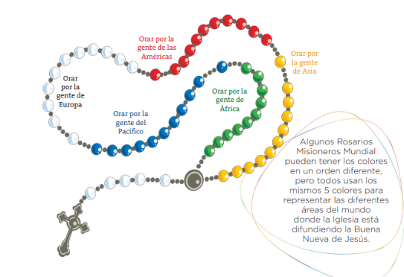
Green beads: represent the forests and grasslands of Africa.
Blue beads: represent the ocean around the Pacific islands.
White beads: represent Europe, symbolize the seat of the Holy Father.
Red beads: represent the Americas, symbolize the fire and faith brought by the missionaries.
Yellow beads: represent the light of the Eastern morning symbolizing Asia.

